EXP 2- MATLAB Simulation of Cellular Coverage, Cell Splitting and Handoff in a Multi-Cell Network
Aim:
To model a simplified hexagonal cellular network and study how cell radius affects coverage, estimated user capacity and handoff as a mobile crosses a cell boundary.
Objectives:
1. Model adjacent hexagonal cell coverage and identify cell centers and boundaries.
2. Estimate the number of cells required to cover a fixed service area for different cell radii.
3. Compare estimated users served under an explicit per-cell capacity assumption.
4. Simulate a mobile moving across a cell boundary and identify the serving-cell transition.
Procedure:
1. Run the MATLAB script below and record the cell area, estimated cell count and total illustrative capacity for each radius.
2. Inspect the hexagonal layout and confirm that adjacent cells share edges without gaps in the idealized tiling.
3. Inspect the mobile-path plot and note the simulated handoff point.
4. Change the service area, radii or users-per-cell assumption one at a time; rerun and compare results.
5. Explain why the geometric cell count and nearest-center handoff differ from an operational cellular network.

PROGRAM:
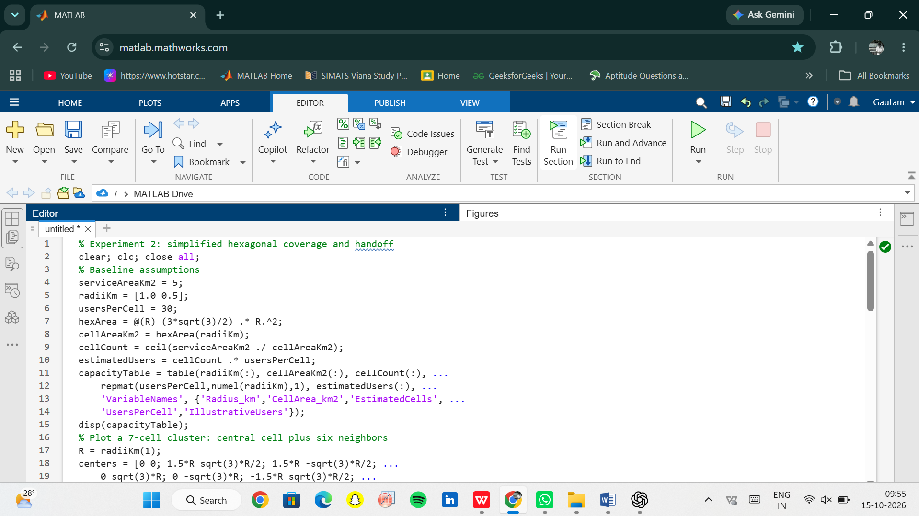
OUTPUT:
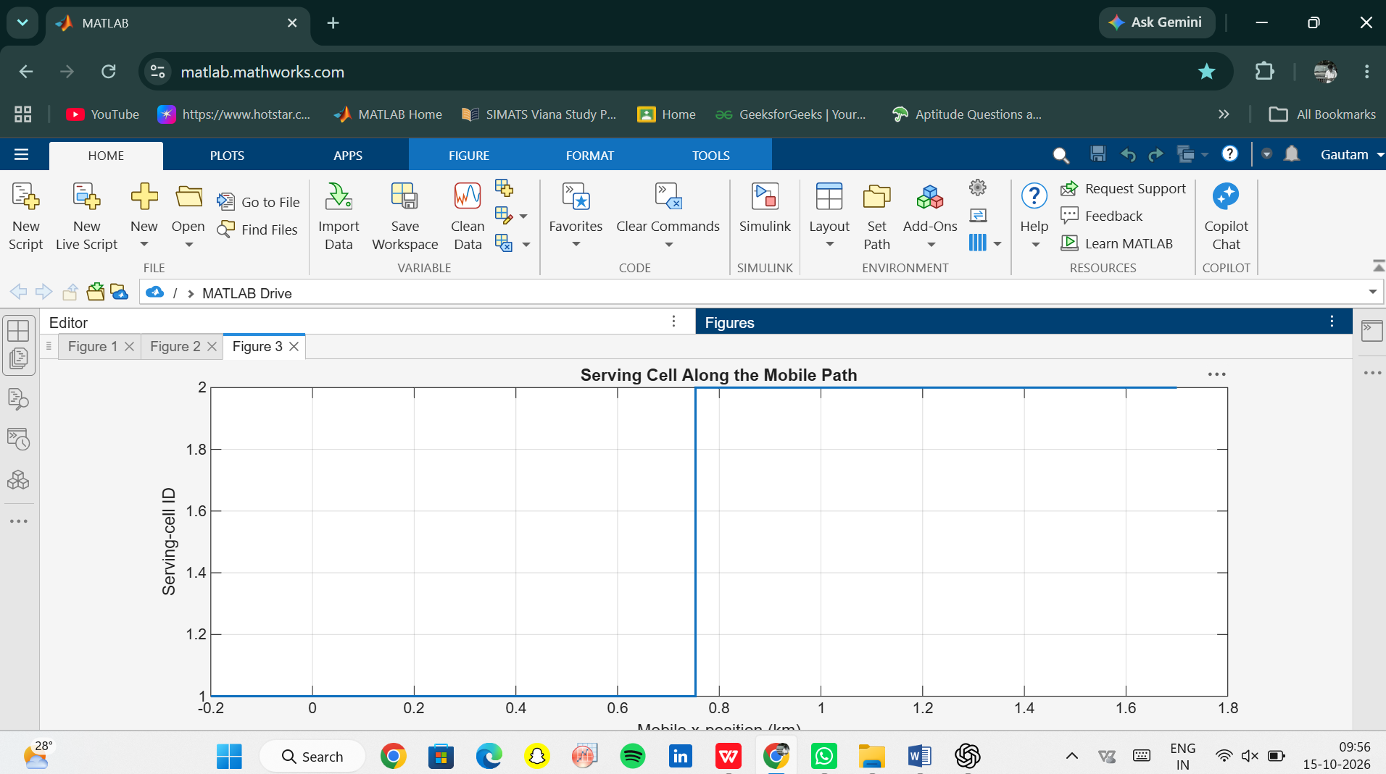

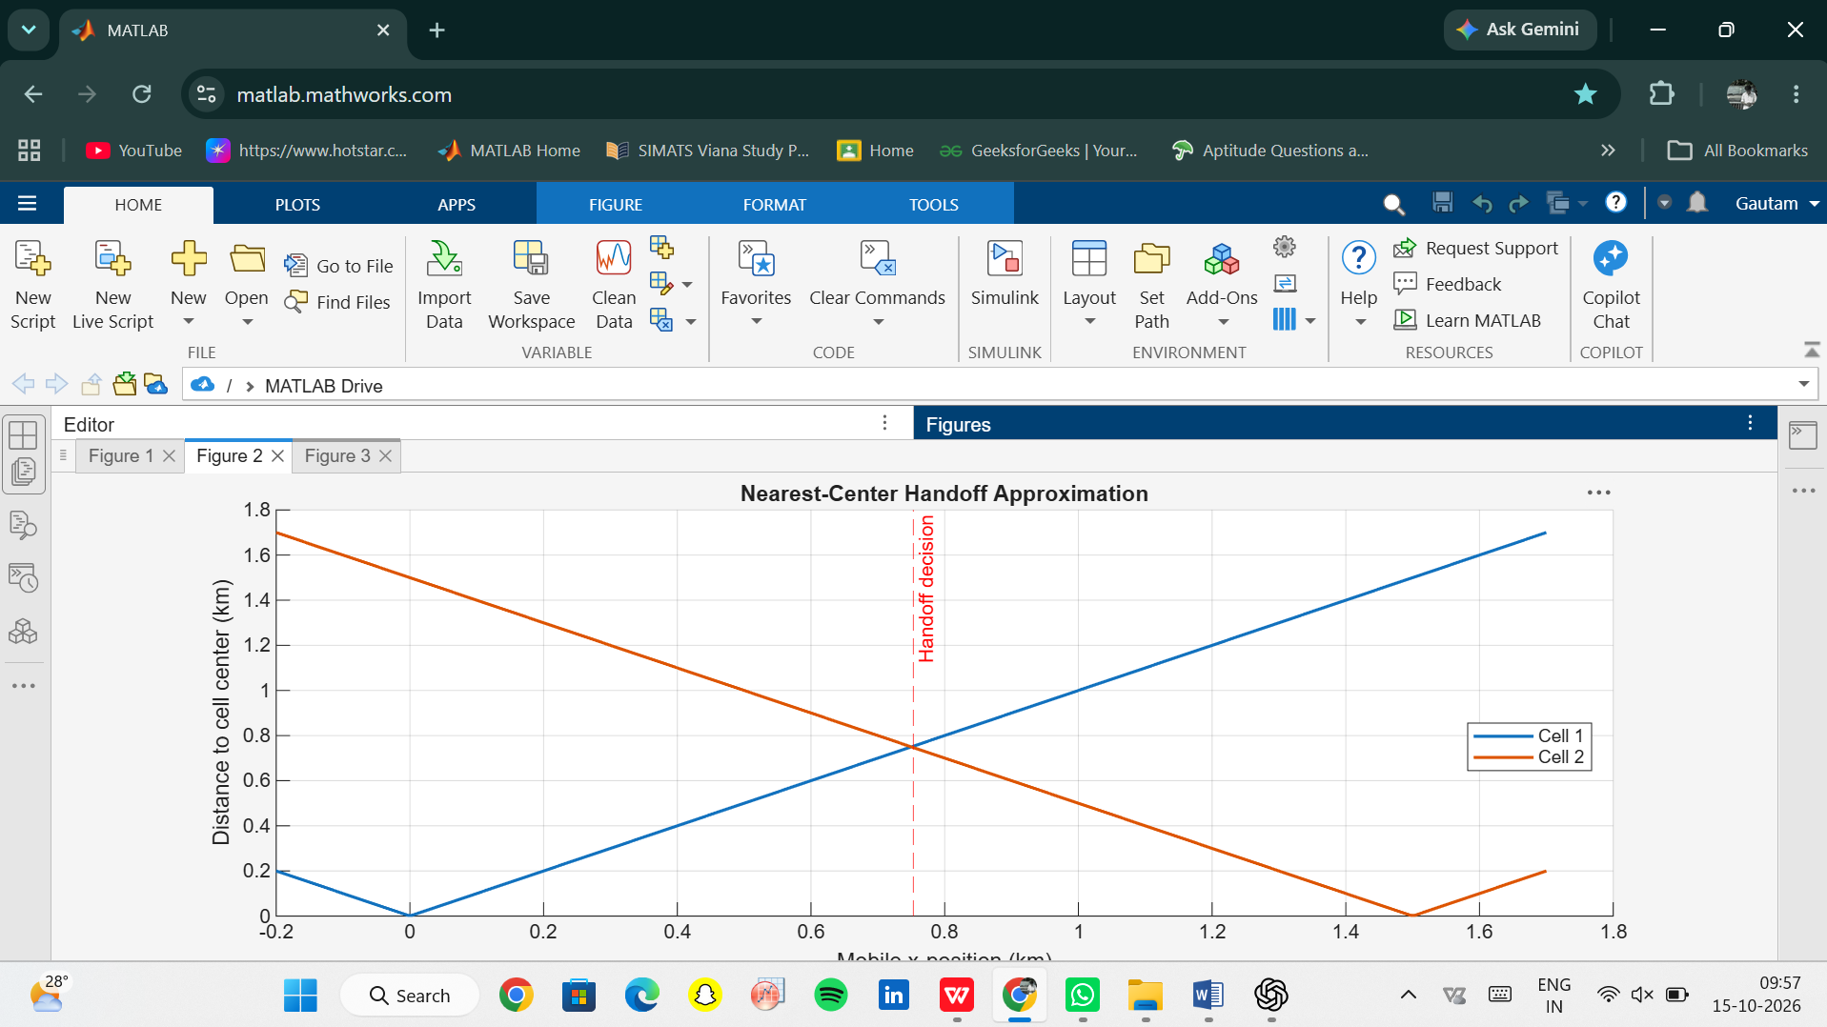

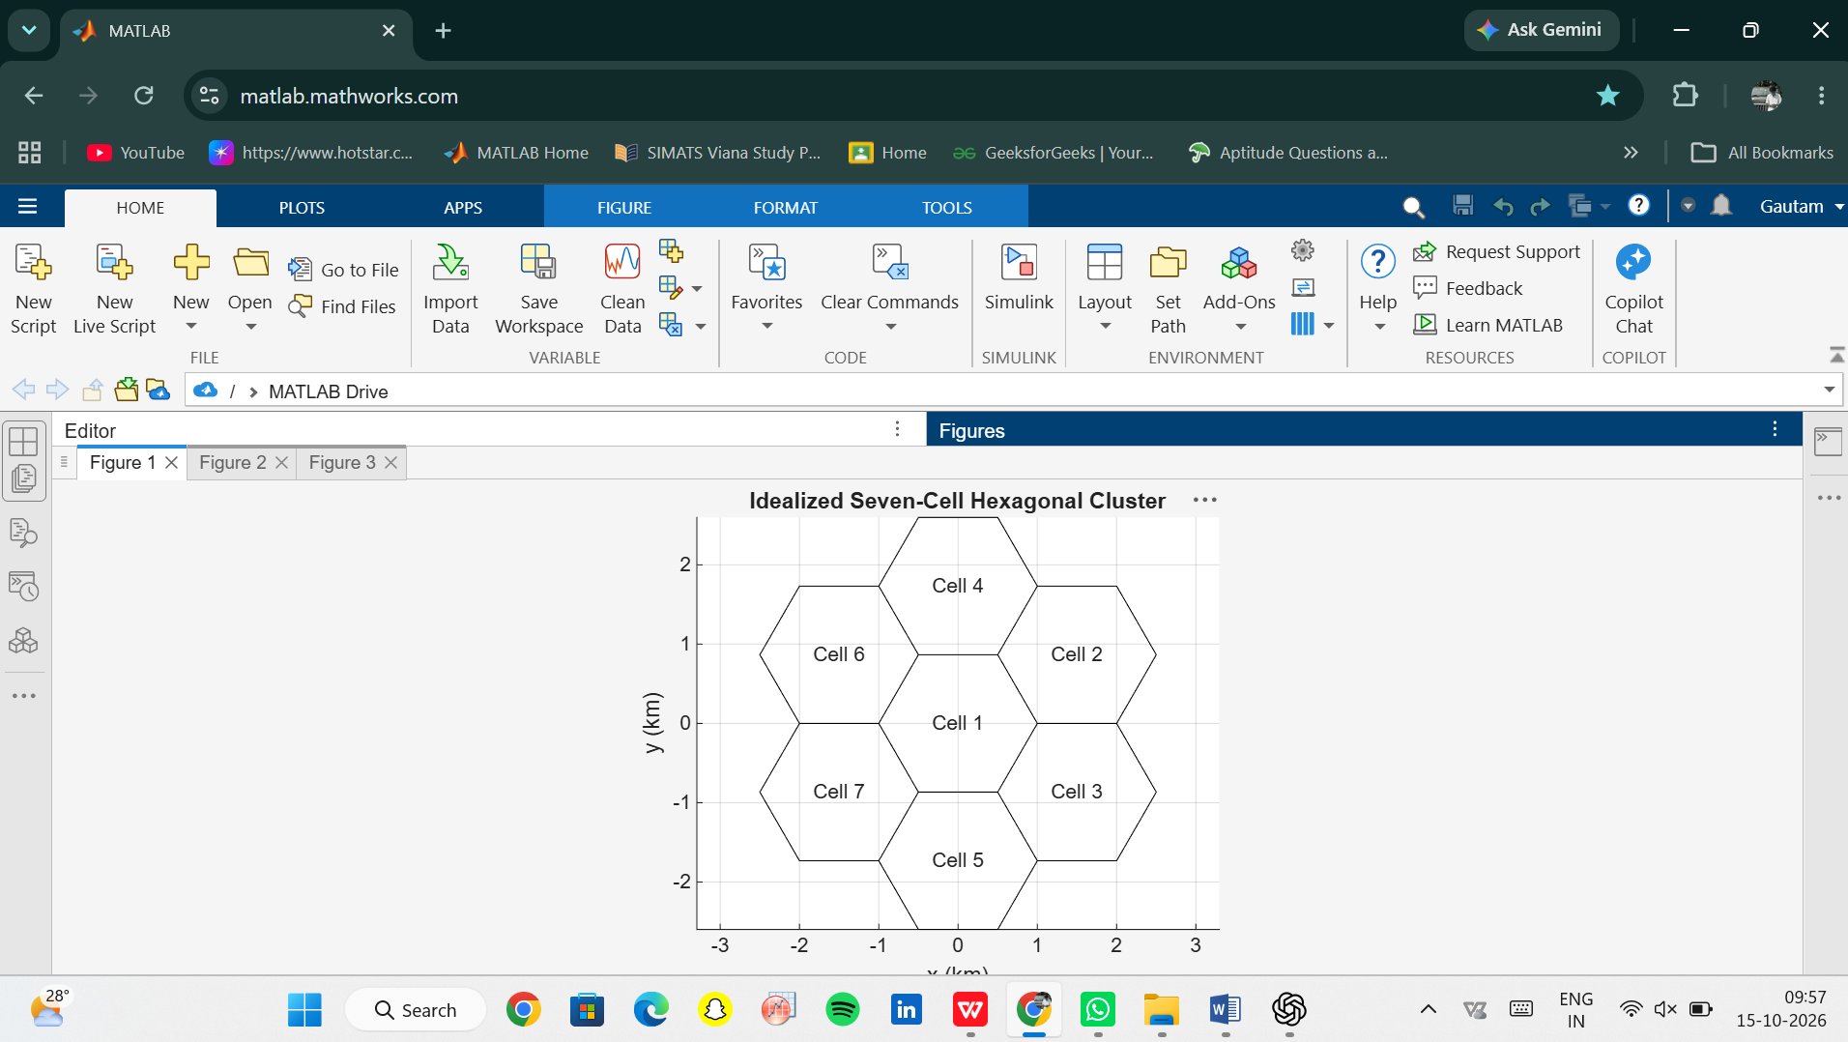

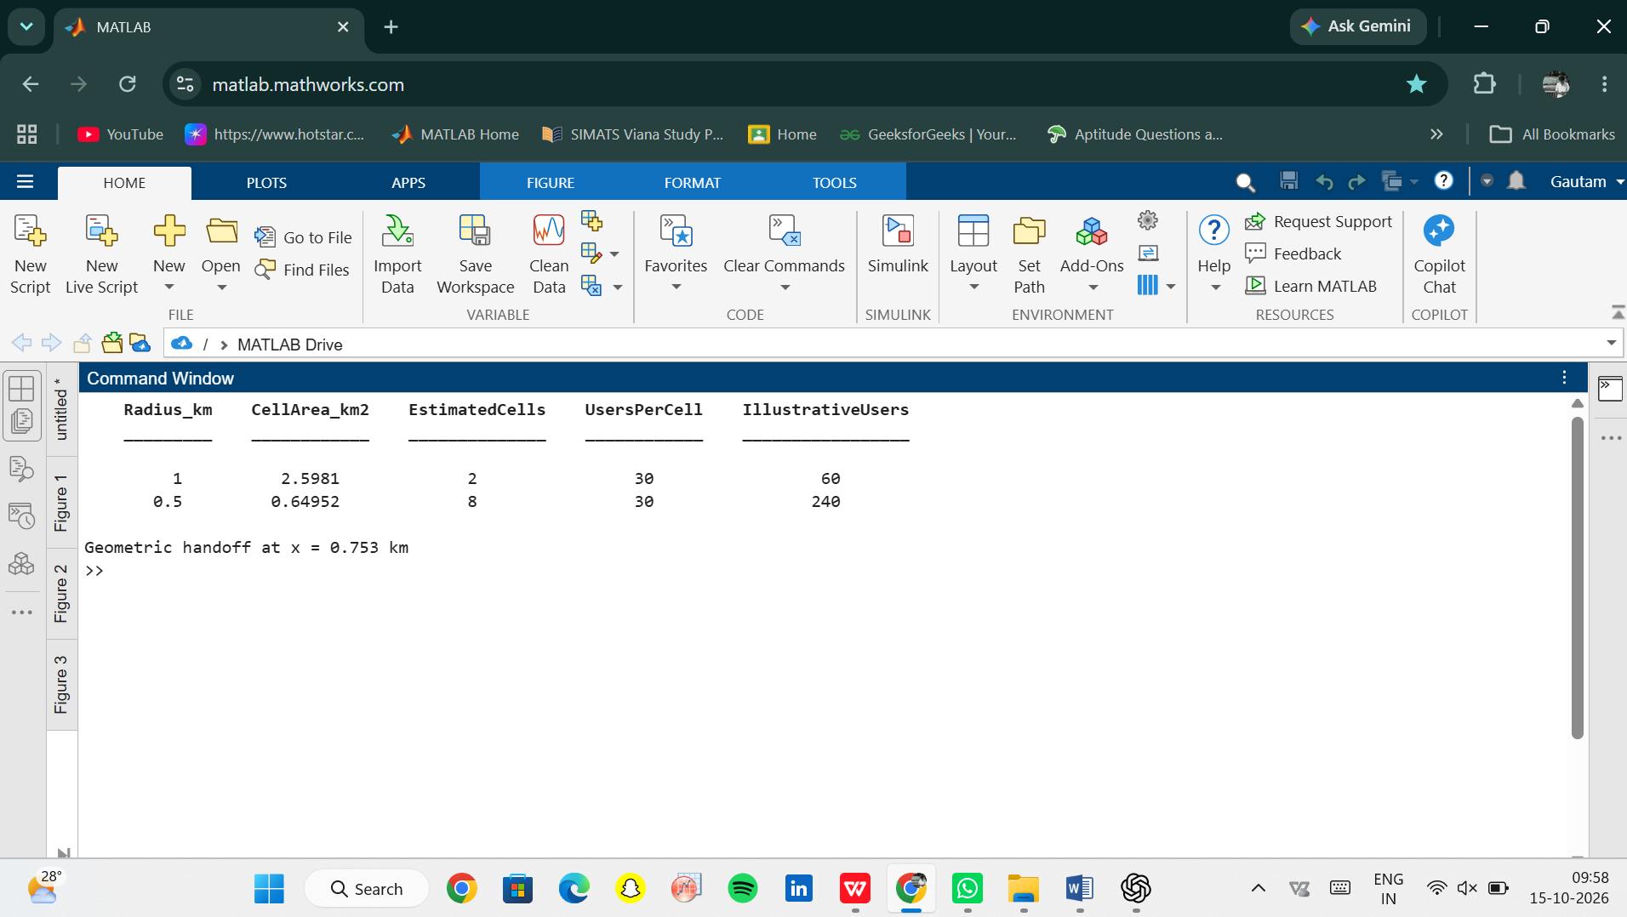

Conclusion:
Summarize how cell radius changes the idealized cell count and assumed network capacity, and report the simulated handoff location. State that the model uses ideal hexagons, an arearatio count, fixed per-cell capacity and nearest-center handoff; it does not model RF propagation, overlap, fading, load or handoff timers

